
Lifelong Learning
Initial Teacher Training
STARTING WITH MINERVA
(With thanks to the Bath Spa University ‘Mark’s Help’ web site)

What 'Minerva' is
Minerva is a teaching tool – Bath Spa University's VLE or Virtual Learning Environment. Minerva is accessed online via a web browser such as Internet Explorer.

How do I log in?
Go to the Bath Spa University home page at:

http://www.bathspa.ac.uk

You will see this screen.
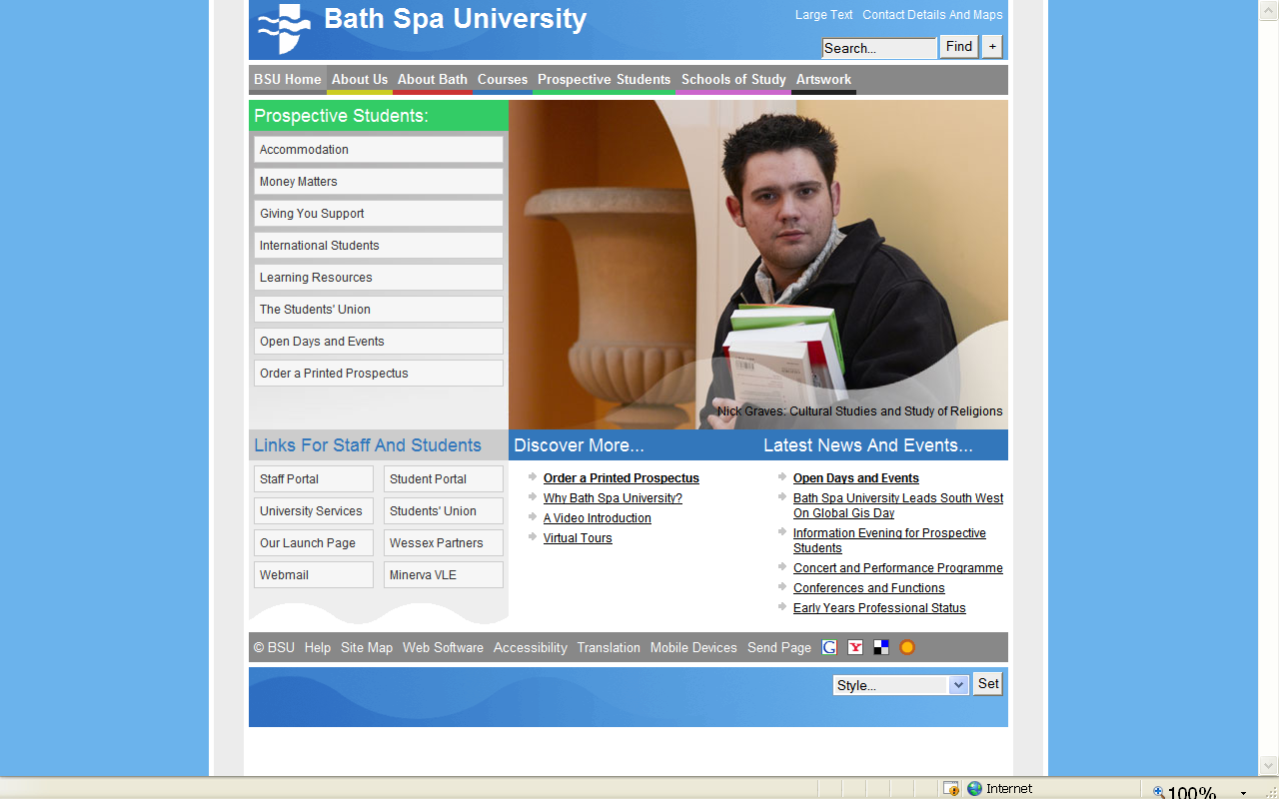
Clicking on the ‘Minerva’ link, or typing the following will take you to the log in screen:
https://minerva.bathspa.ac.uk/webapps/login/

Log in by entering your Bath Spa University username and password in the correct spaces, and clicking on the ‘login’ button.

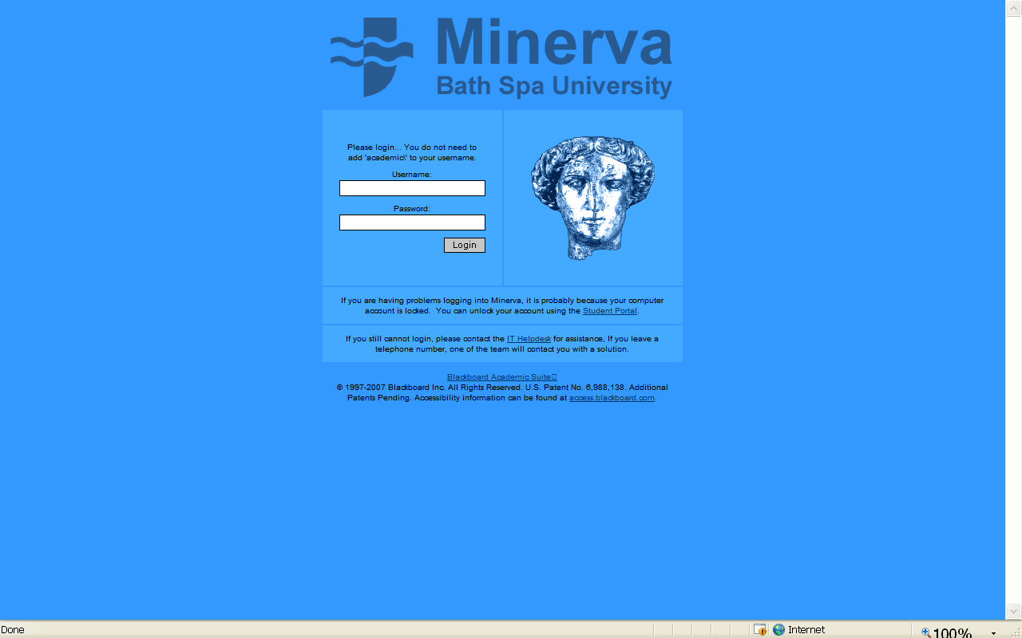
Once logged in you will see a screen which lists the modules you are enrolled in:

You are enrolled in the Lifelong Learning Initial Teacher Training and Professional Development area, which will appear as shown below.

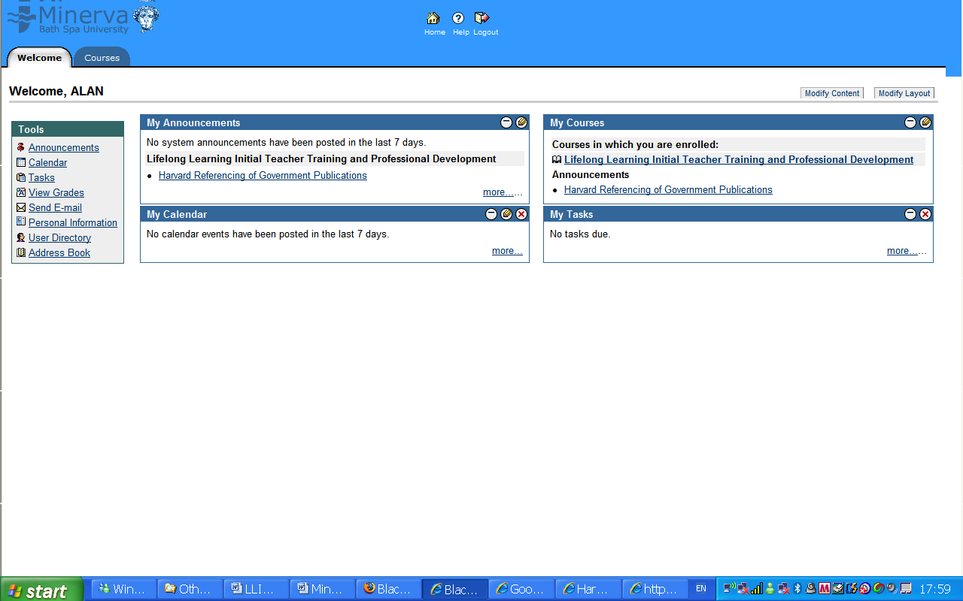
Click on the title and you will the see the screen below:

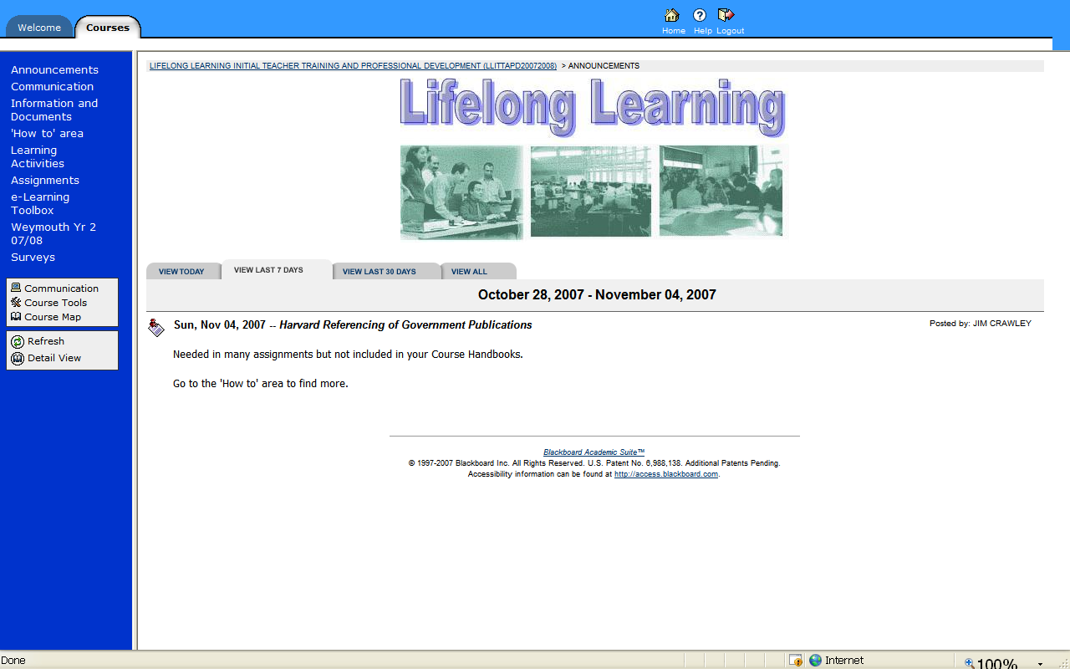

To find the ‘Staff Zone’
Click ‘Information and Documents’ on the menu in white down the left hand side of the page. You will see this screen.
Click on ‘THE STAFF ZONE’

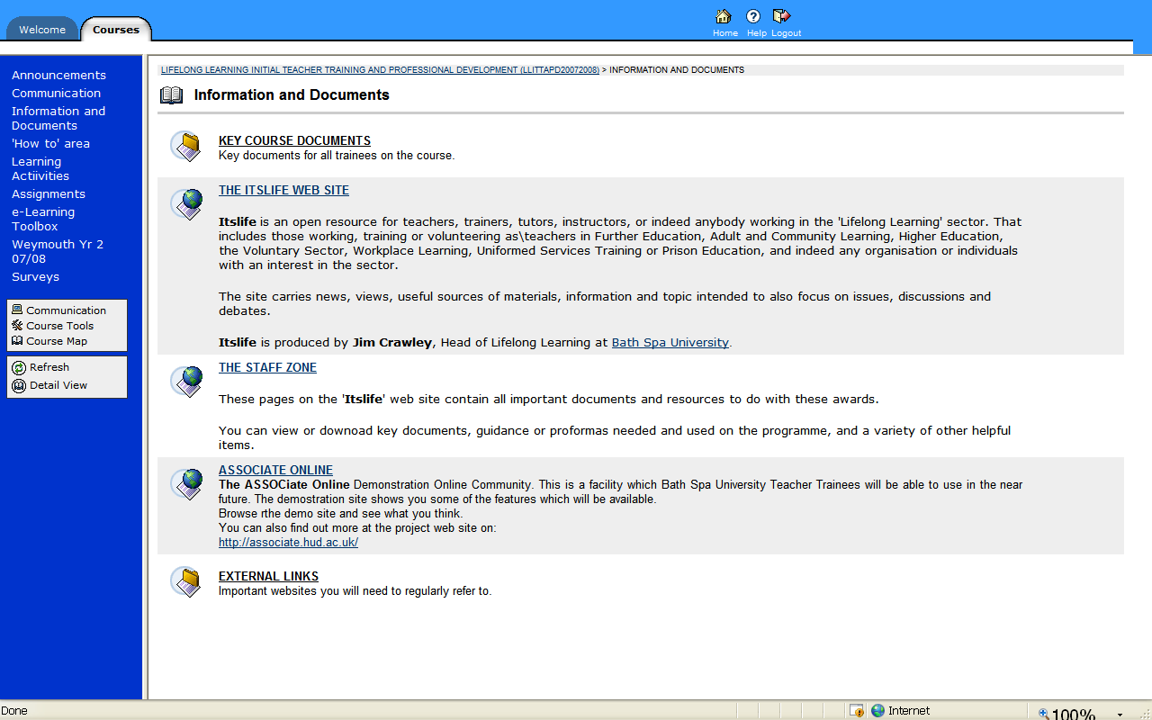

You will see this screen:

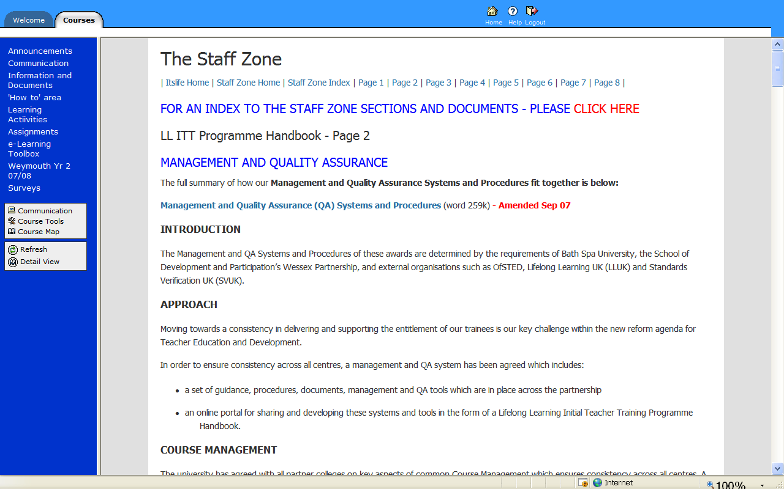

Other items on the course menu are:

- Announcements – features regular news, deadlines and updates
- Communication – Includes discussion boards and other tools for communication. There are two discussion boards already set up.
- Information and Documents – A series of important items / external links and documents. A link to the Staff Zone is in this area.
- 'How to' area – Help Pages on various items such as Minerva
- Learning Activities - A developing area for online learning activities
- Assignments – the place where students submit their coursework electronically for a plagiarism check
- e-Learning Toolbox – a series of sources of advice on making better use of e-learning in your teaching
- Weymouth Yr 2 07/08 – content for a particular group, but visible to all
- Shared Resource Bank – An area all can contribute to, and all staff can add items to.
- Surveys – under development

IF YOU ARE NOT ABLE TOP ACCESS THE STAFF ZONE IN THIS WAY, YOU CAN GAIN DIRECT ACCESS BY TYPING:
http://www.itslifejimbutnotasweknowit.org.uk/staff-start.htm

