
VIEWING WORK SUBMITTED TO JISC PLAGIARISM DETECTION SERVICE OR TURNITINUK – DECEMBER 2007

Once logged in to 'Minerva', select the Lifelong Learning Initial Teacher Training area, and then the 'Control Panel' from the menu in the grey area lower down the screen. You will see this list.
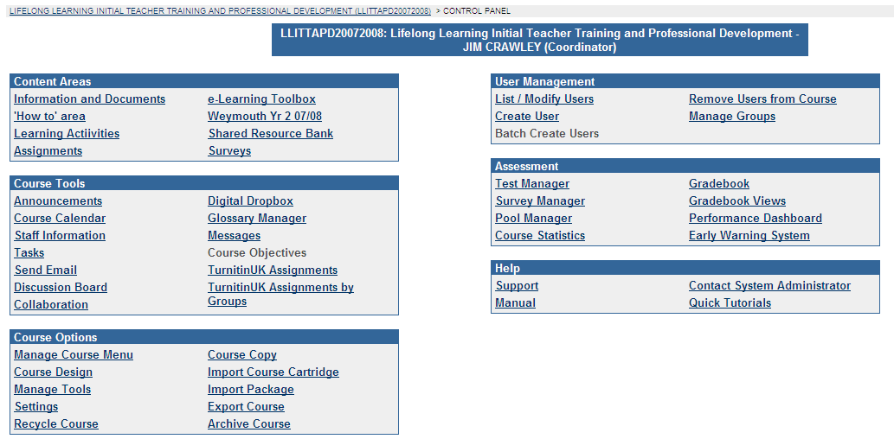

Click on the 'Turnitin UK Assignments'. A list of the course assignments which have to be submitted to Turnitin appear. Click on LL1007.2, which appears as below


You will see a list of names. If the work has been submitted the names will look as below:
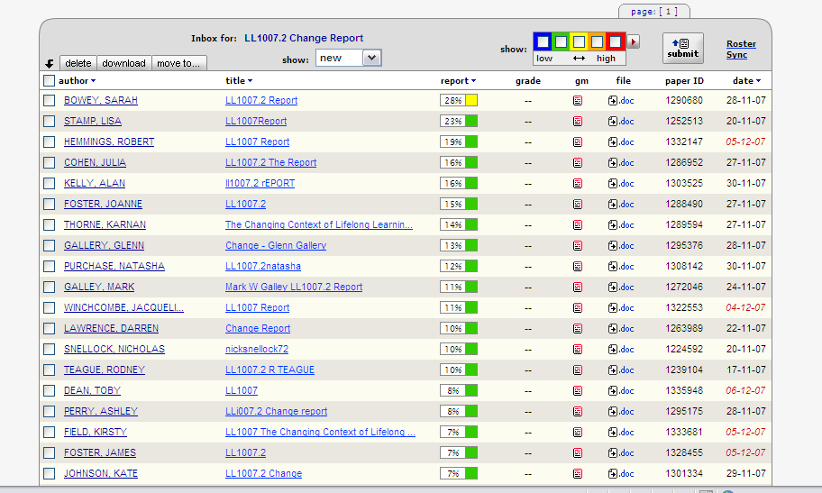

If work has not submitted there will be a list of names, but ‘no submission’ against the name.
To look at a plagiarism report
Click on the coloured box in mid screen with a percentage next to it.
The report will look something like this
