GROUP PLANNING ACTIVITY

An interactive exercise

Planning a Course or Learning Programme

SCENARIO

Your group will plan a short (6 week) course on one of the following areas (or another of your own choice):

Better health

Safety in the work situation

Travelling in Europe

Developing study skills

Life, the Universe and Everything
Planning a course / learning programme

This exercise is designed to take the group through a series of discussions. Questions are posed for the group to consider and spaces are left for you to record answers. By the end of the session you will have constructed an accessible sequence of information which will provide the data for your scheme of work.

The whole group should set about the task in the first place but you might find it necessary or useful to split into sub-groups to complete some aspects of the task.

Task rationale

However expert you may be in your subject the primary aim of your course must be that your students should learn; the emphasis throughout the planning and implementation of a course must be on student learning rather than on your teaching. Your skill in designing a course to enable your students to learn will be far more important to them in terms of their learning than the quality/quantity of your subject expertise.

Throughout the planning keep the following in mind:

- Students will be adults
- They attend for a variety of reasons, with a variety of needs
- They may have particular learning difficulties associated with adults
- They will have useful experiences on which to draw
- Learning is going to take place in part in a group situation
- Learner participation in the course is essential
- The whole environment – atmosphere, comfort, simulation are all important and will affect how well students learn
- Continuous evaluation of the course is essential


STEP 1 – AIMS

Choose a scenario from page 2. Write an aim or aims for the course – i.e. a statement of general intent, a vague direction. Discuss this and write in the space below.

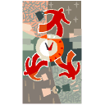
STEP 2 – TARGET GROUP

Look at your aim(s). Does this imply a level for your learners? For example, is it to be aimed at beginners, or will participants require some prior knowledge? Are entry requirements required? Describe the target group below, including any knowledge levels required.

STEP 3 – OBJECTIVES

What will they learn? What will the course achieve for them? Write a series of objectives for the course you are planning. Consider whether they will be ‘product’ or ‘process’ oriented or a mix of the two. Aim for between 6 and 8 objectives.

Check your objectives against this list:
- If product oriented, do they state what participants will be able to do as a result of the learning?
- Have you included affective and psychomotor objectives?
- If process oriented do they focus on the experiences the learners will undertake?
- Are your objectives worthwhile and relevant?
- Are they SMARTER? Are they realistic? Can they be achieved in the time?
- Do they link with your original aim?
STEP 4 - VENUE

Where will your course take place? College Campus, community centre, workplace…… what would be the most appropriate?

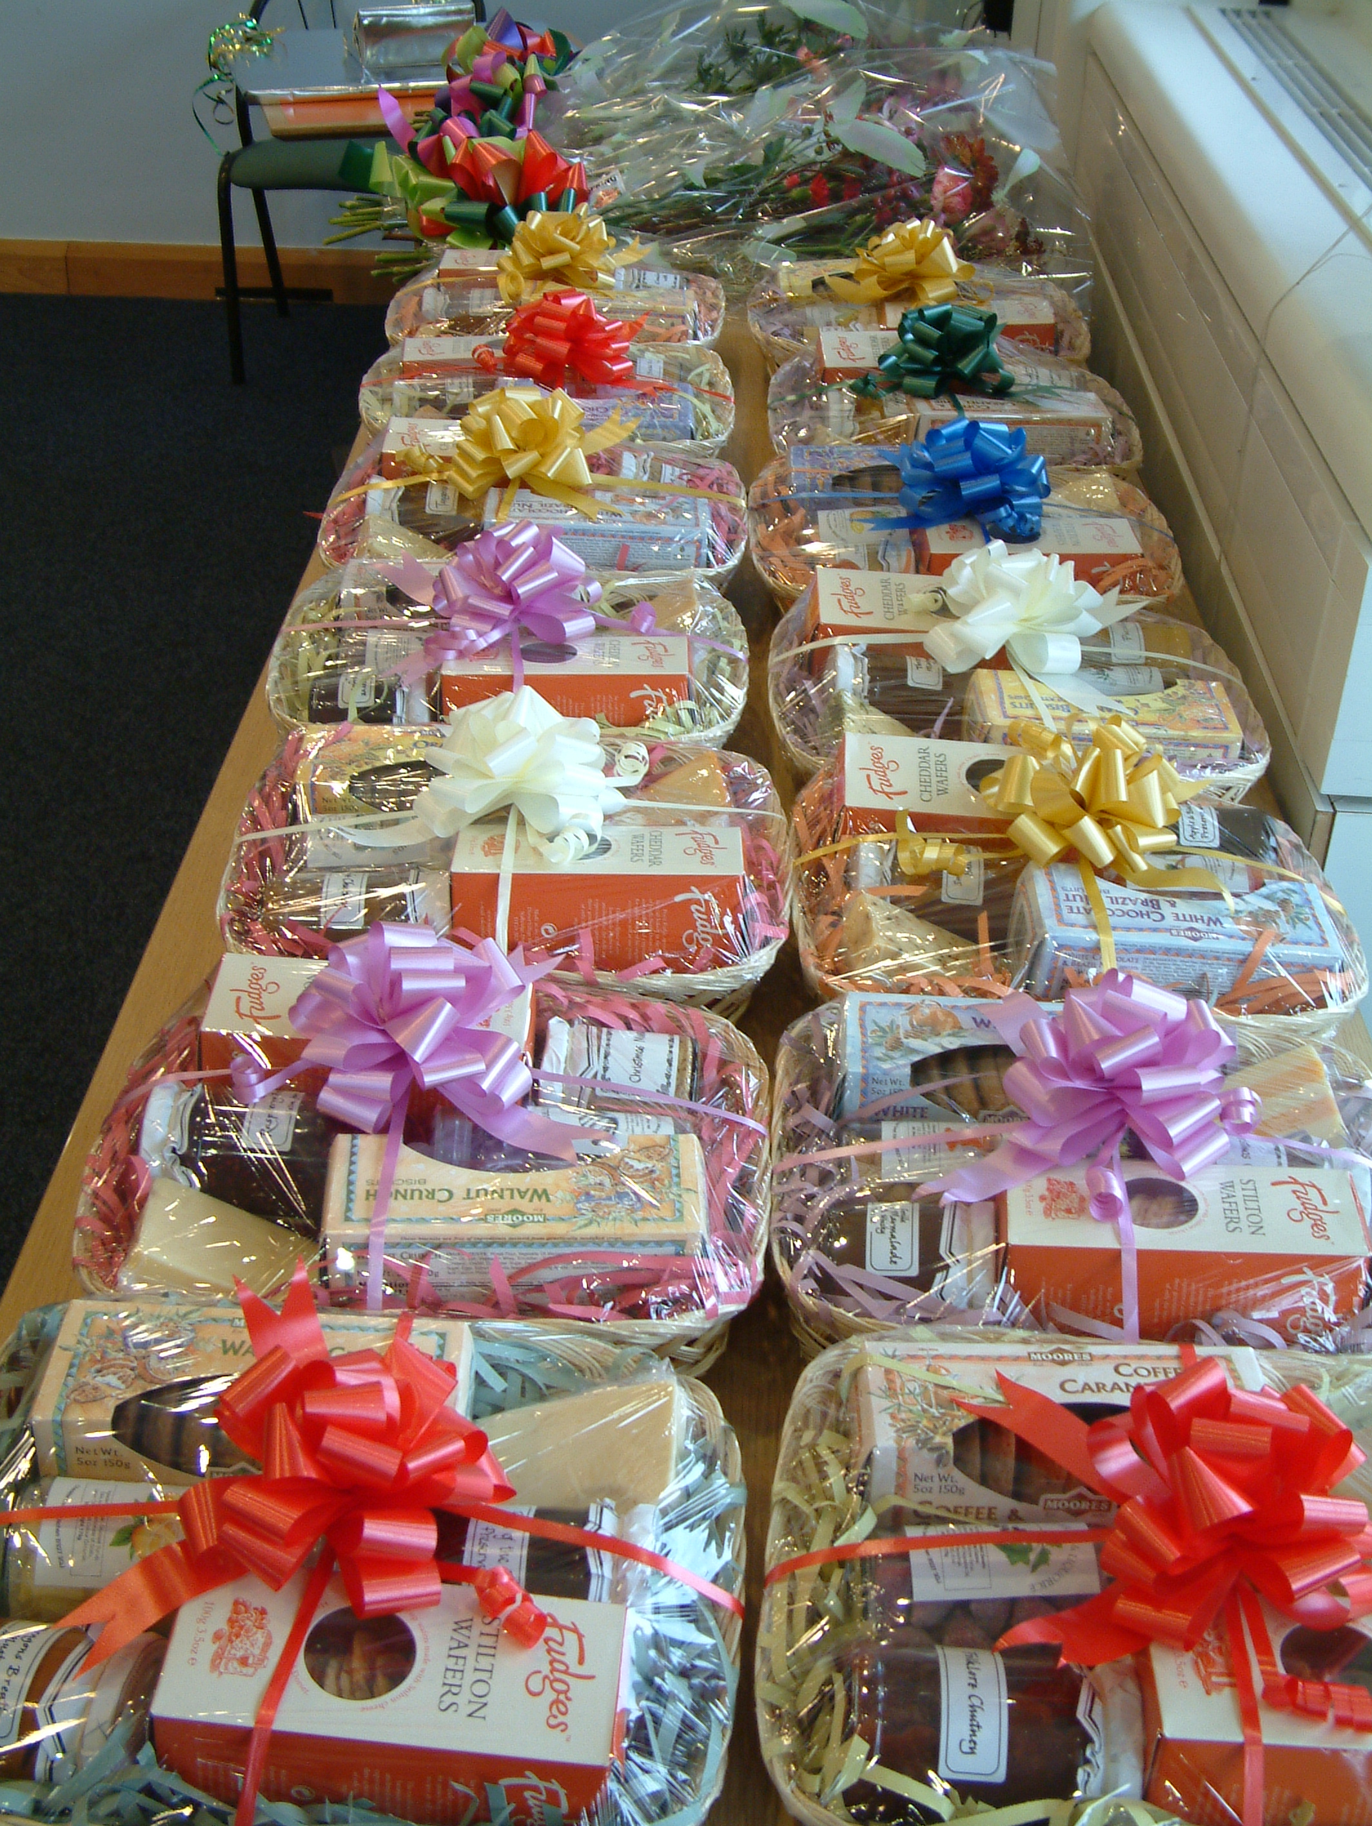
STEP 5 – CONTENT

From your list of objectives, construct a list of topics which the course content might include. This is the course syllabus.

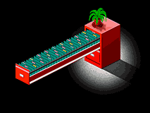
STEP 6 – TOPIC ORDERING
Look at the list of topics. They need to go into some logical sequence. Are there motivational reasons to put some topics before others? Think about topic precedence – try and produce a topic precedence diagram.

STEP 7 – TIMING
Now decide what would be the best way to split up the hours allowed for the course. Approximately how much time will each topic be allocated? How will that correspond to the session lengths?


STEP 8 – EQUALITY AND DIVERSITY
Are there any issues of equality and diversity you need to consider? Is the venue accessible? Should or will your course appeal to both genders? Are you likely to have to tackle stereotyping or prejudice in response to the content of the learning?

STEP 9 – SKILLS FOR LIFE
Can you embed language, literacy and/or numeracy into your course? Which skills will naturally develop with the course content?


STEP 10 – E-LEARNING (ILT)
How can you use ILT or e-learning in the course? Provide a list of appropriate websites, or communicate by email? Use an electronic whiteboard?

STEP 11 – EVALUATION

How will you evaluate the effectiveness of the course? Where will you build formal evaluation in – at the end or throughout?

Now you should have enough background information to be able to write up your scheme of work.

- Fill in the front sheet
- Divide your content into sessions
- In the Topic column, list a few ideas for teaching and learning methods for each session as well as the main topic(s) to be covered
- Decide how you will monitor learning and assess learners’ progress
- Decide the resources you are likely to need
- Use the final column to make any specific notes or reminders to yourself (e.g. Check guest speaker can make next session)

