ASSESSMENT - BEING INCLUSIVE

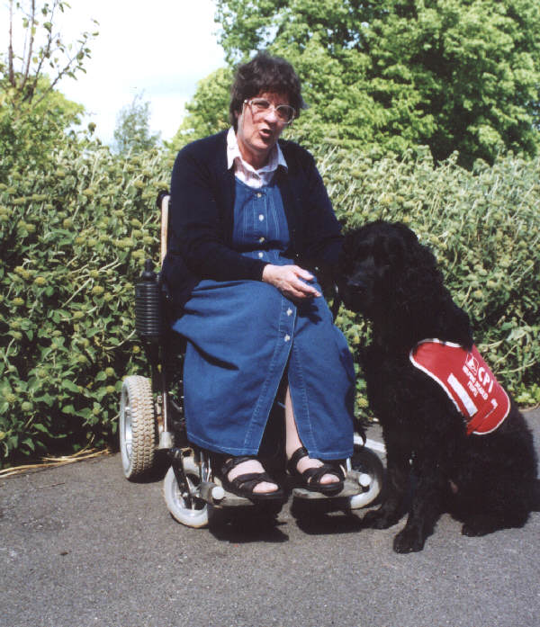
In each of these examples, what can you do to make assessment more inclusive ?

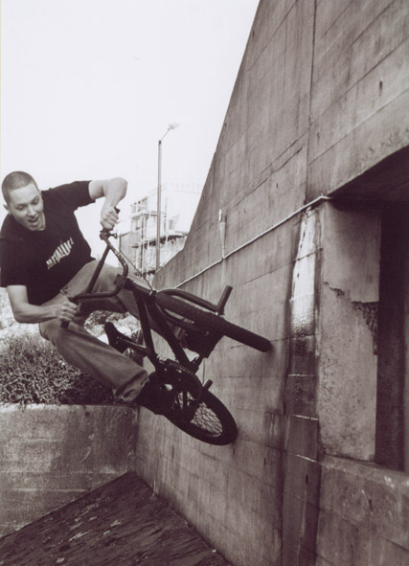
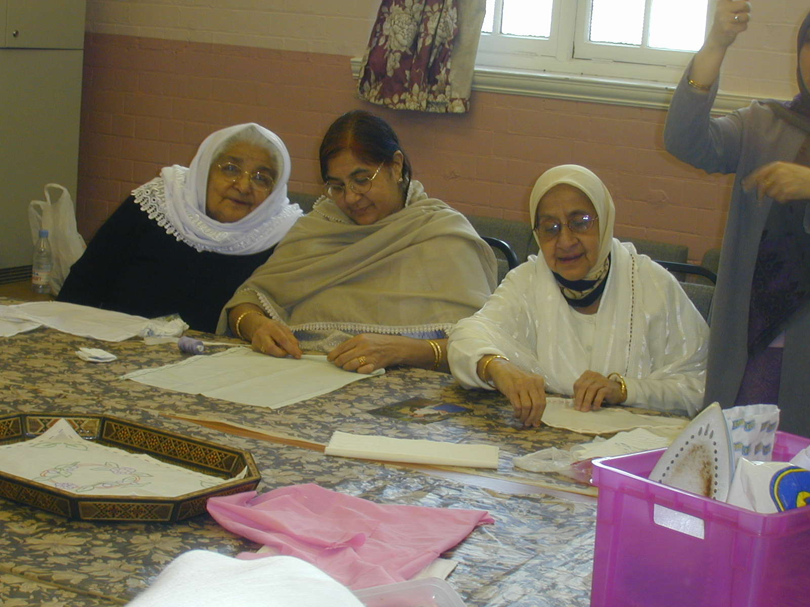
Jane is the secretary of a local voluntary organisation.

She lives ten miles from the community hall where

the ‘Supporting Voluntary Organisations’ course is
running. She doesn’t have transport. The course has
a portfolio-based qualification at level 2, which Jane
is really keen to get. Of the 25 sessions for which
the course runs she knows she can’t attend four,
due to her regular checkups.

This is an Asian women’s ‘craft

Workshop’ course, offered at a

community centre nearby. The women

speak some English, and there is an
interpreter at all classes. The students
don’t want a qualification, but want to
know how they are progressing, and
to have some recognition
of their skills.

There is a group of young adults, who are not at
the moment engaged in education at all. They have
been telling a local youth worker that they would like
to try out ‘something practical’. They agree to try out
a ‘taster’ in bike and car maintenance, for which
you and they need evidence of what they are capable
of, and what they may be able to go on to next.

