Learning Theories Revision
Behaviourism
- Founders and proponents: John B. Watson in the early 20th century. B.F. Skinner, Ivan Pavlov, and others.
- Basic idea: Stimulus-response. All behaviour is caused by external stimuli (operant conditioning). All behaviour can be explained without the need to consider internal mental states or consciousness.
- Learner viewed as: initially passive but responsive to stimuli.
- Behaviour may result in reinforcement (increased likelihood that behaviour will occur in the future); or punishment.
Cognitivism
- Founders and proponents: Noam Chomsky in the 1960s.
- Basic idea: Mental function can and should be understood.
- Learner viewed as: Information processor.
- Cognitivism focuses on inner mental activities — opening the “black box” of the human mind. It is necessary to determine how processes such as thinking, memory, understanding, and problem-solving occur. People are not “programmed animals” that merely respond to environmental stimuli; people are rational beings whose actions are a consequence of thinking.
- Metaphor of mind as computer: information comes in, is being processed, and leads to certain outcomes.
Humanism
- Founders and proponents: Abraham Maslow, Carl Rogers, and others.
- Basic idea: Learning is a personal act, to fulfil one’s potential.
- Learner viewed as: One with affective and cognitive needs.
- Emphasis on the freedom, dignity, and potential of humans.
- Learning is student-centred and personal, facilitated by teachers, with the goal of developing self-actualised people in a cooperative, supportive environment.
- Freedom to Learn is a prime example of a Humanistic approach.
Multiple Intelligences Theory
Developed by Harvard psychologist Howard Gardner in 1983 and subsequently refined, this theory states there are at least seven ways (“intelligences”) that people understand and perceive the world. These intelligences may not be exhaustive. Gardner lists the following:
- Linguistic. The ability to use spoken or written words.
- Logical-Mathematical. Inductive and deductive thinking and reasoning abilities, logic, as well as the use of numbers and abstract pattern recognition.
- Visual-Spatial. The ability mentally to visualise objects and spatial dimensions.
- Body-Kinaesthetic. The wisdom of the body and the ability to control physical motion.
- Musical-Rhythmic. The ability to master music as well as rhythms, tones and beats.
- Interpersonal. The ability to communicate effectively with other people and to be able to develop relationships.
- Intrapersonal. The ability to understand one’s own emotions, motivations, inner states of being, and self-reflection.
This theory, while widely popular over the last two decades, has its share of critics. Some argue that Gardner’s theory is based too much on his own intuition rather than empirical data. Others feel that the intelligences are synonymous for personality types.
Experiential Learning (Kolb)
Building upon earlier work by John Dewey and Kurt Levin, American educational theorist David A. Kolb believes “learning is the process whereby knowledge is created through the transformation of experience” (1984, p. 38). The theory presents a cyclical model of learning, consisting of four stages shown below. One may begin at any stage, but must follow each other in the sequence:
- concrete experience (or “DO”)
- reflective observation (or “OBSERVE”)
- abstract conceptualization (or “THINK”)
- active experimentation (or “PLAN”)
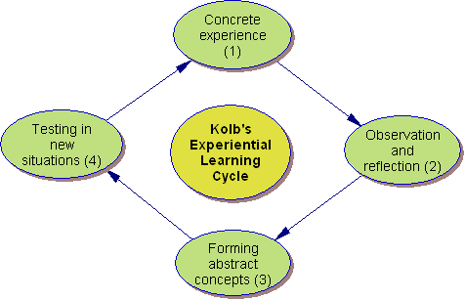
Figure 1 Kolb’s Experiential Learning Cycle.
Kolb’s four-stage learning cycle shows how experience is translated through reflection into concepts, which in turn are used as guides for active experimentation and the choice of new experiences.
For more information, see:
- Kolb, David A. 1984. Experiential Learning: Experience as the Source of Learning and Development. Prentice-Hall, Inc., Englewood Cliffs, N.J.

http://www.learning-theories.com/experiential-learning-kolb.html [Accessed 24/09/2010]

