STEP programme follow-up day 23rd September 2011

Preparation Shoe Box Activity

To prepare for this activity you need to select three items that represent things that are important to you in your life. You should bring these with you to the session on 23rd September.

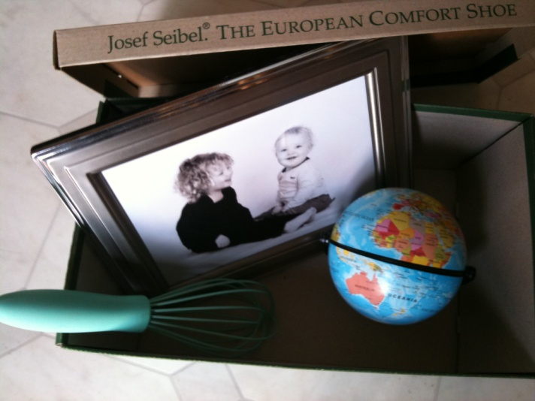
Remember:

- The items you bring should all be able to fit in a shoe box
- You should be prepared to share what these items represent
- These items should help you explain briefly what is important to you

At the session you will be asked to share the three items you have brought and what they represent. This activity will help us think about what is important to us as individuals. Sharing our items will help us to get to know each other a little better.

